**DOCUMENT ON JOINS**

**WHAT ARE JOINS ?**

Joins are used with selected statement , used to retrive the data from multiple table from same database. Fetching the records from different tables will be very easy.

There are 3 types of MySQL Joins:

1.INNER JOIN

2.LEFT JOIN

3.RIGHT JOIN

**INNER JOIN**

In order to written all the rows from multiple tables where the join condition is satisfied

This is the most commonly used joins in MySQL.

select * from vegetables inner join fruits on vegetables.taste = fruits.taste;

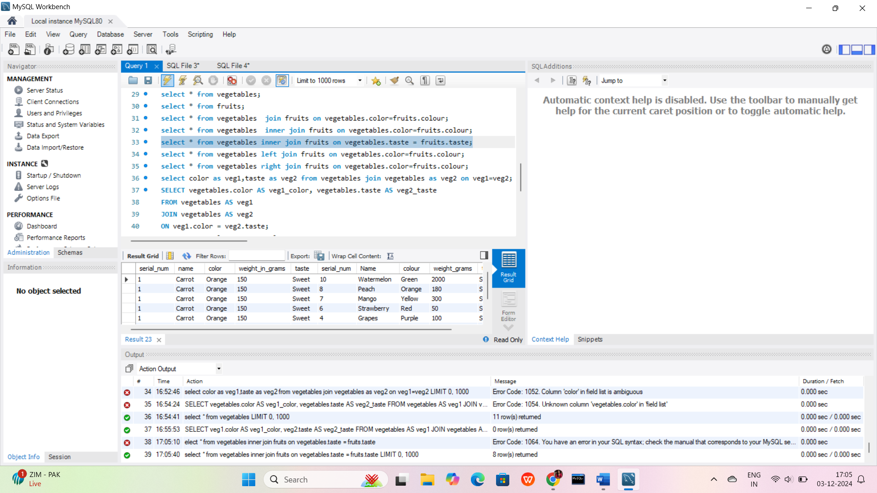

**LEFT JOIN**

Return all row from the left hand side table and all the rows from right hand side by satisfying the join condition.

select * from vegetables left join fruits on vegetables.color=fruits.colour;

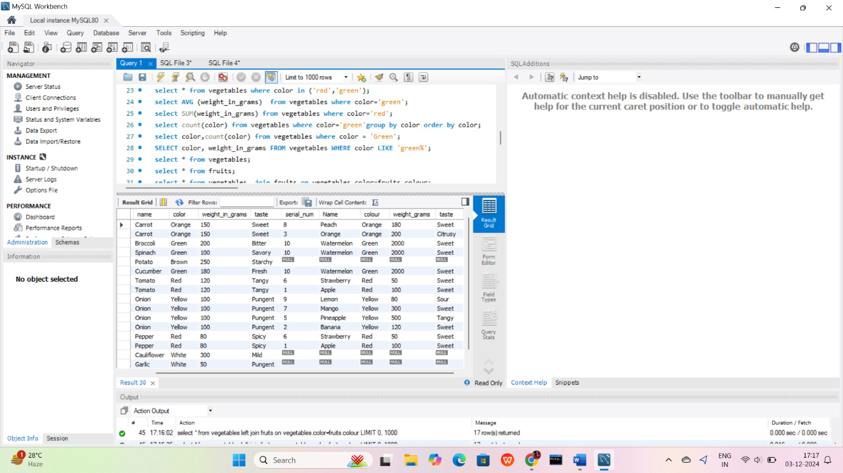

**RIGHT JOIN**

Return all rows feom the right hand table with right hand table rows on to the right table by satisfying the Join condition.

select * from vegetables right join fruits on vegetables.color=fruits.colour;

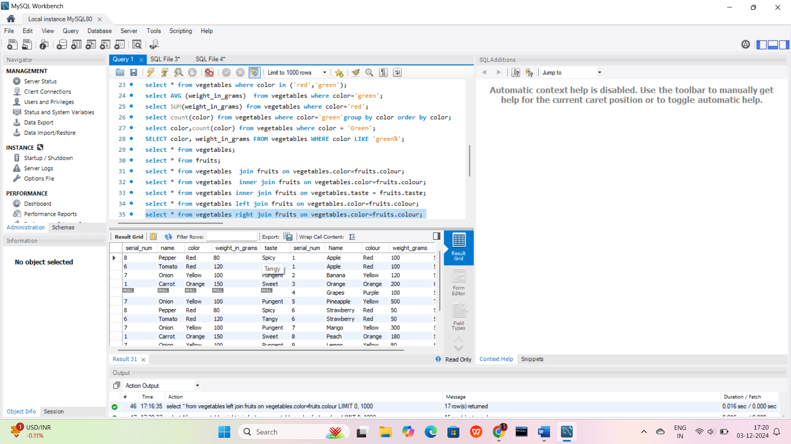

**SELF JOIN**

The data/rows in the table are connected/joined with the same data/rows in the same table

SELECT * FROM vegetables self join vegetables**;**

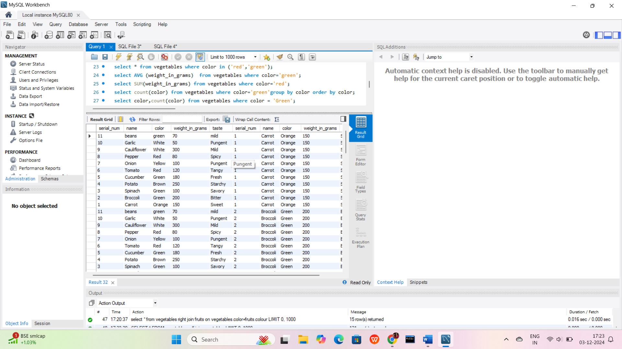

**CROSS JOIN**

Return all the records from both the tables

select * from vegetables cross join fruits;

